Implementation Plan for Secure Host and Computational Storage Communication
SafeConnectKey prototype validation results and demonstration evidence
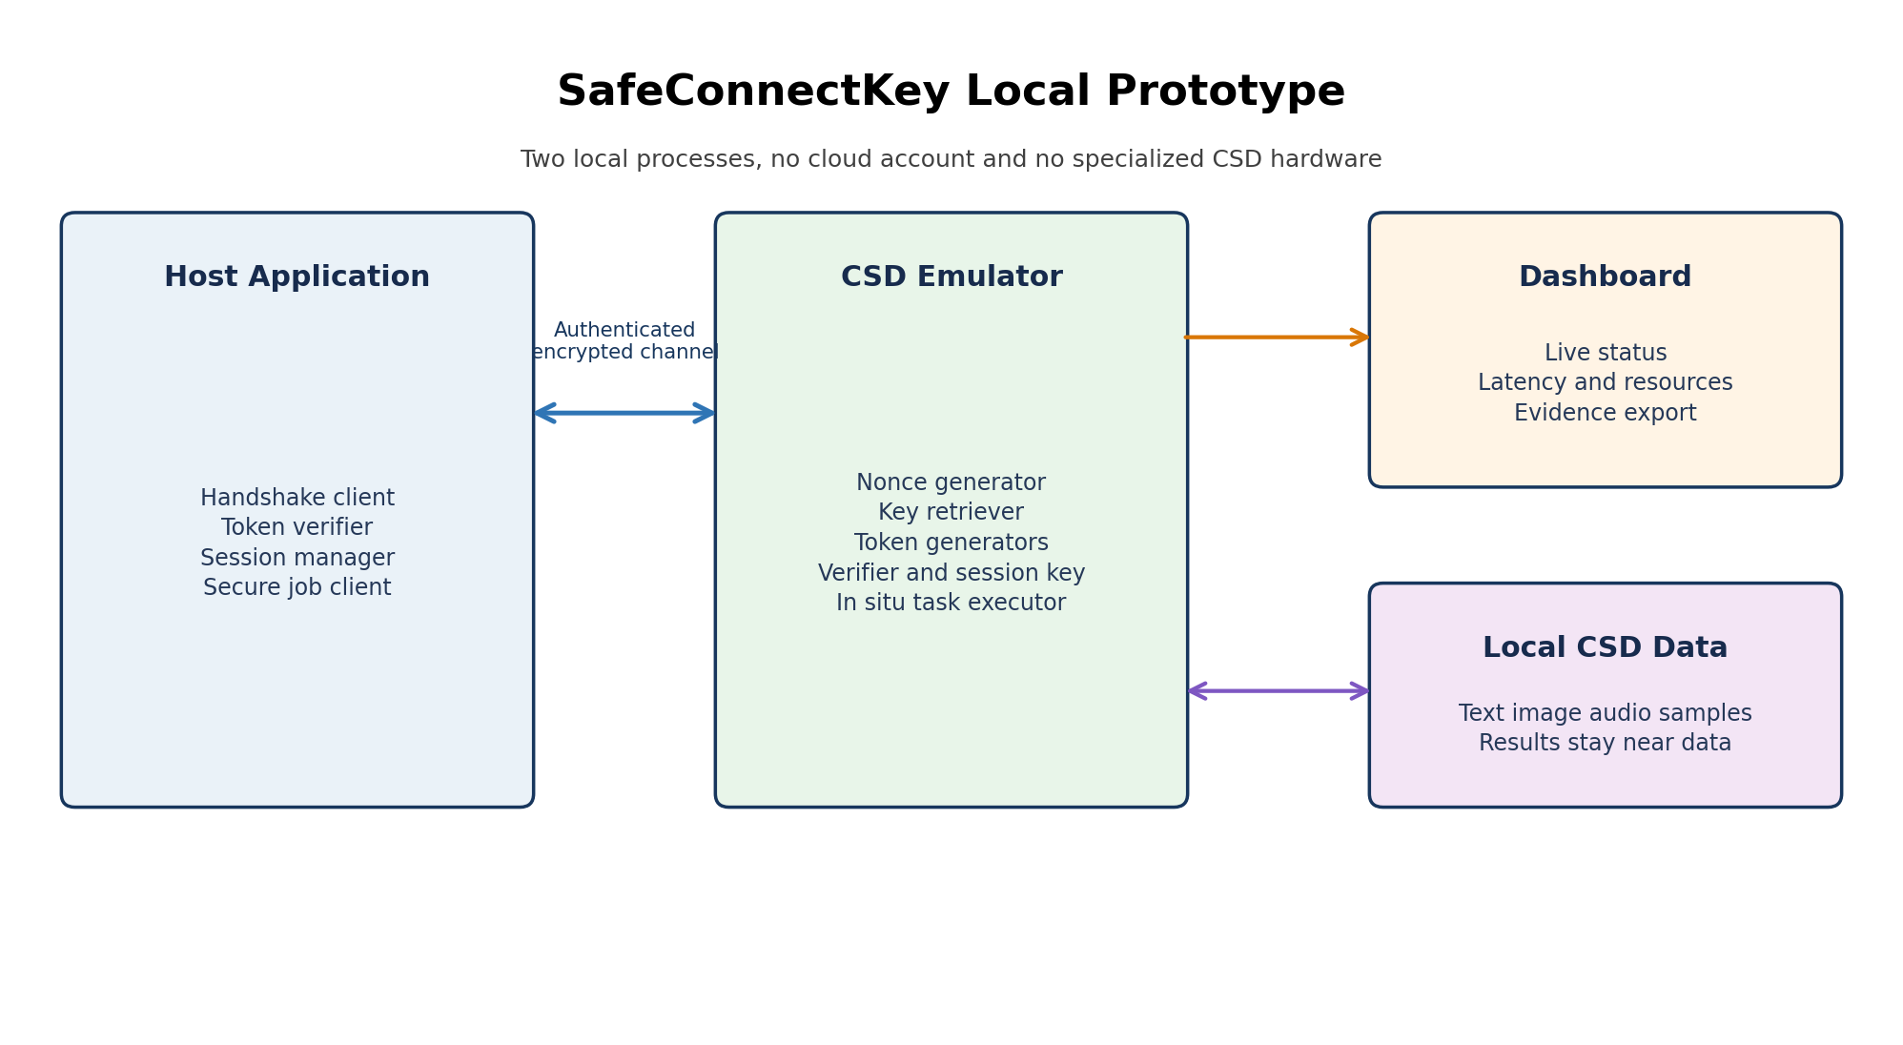
Recommended local prototype architecture
Prepared for Vellore Institute of Technology project implementation
Document purpose Build the prototype and produce defensible validation evidence
Cost constraint Local and open source toolchain with no credit card required
Date 25 October 2026

Executive Summary
The most practical implementation is a local software emulation of a Host and a Computational Storage Drive. Two independent processes communicate over localhost or a private virtual network. The CSD process stores sample data, performs lightweight in situ jobs, executes the authentication handshake, derives a session key, and returns encrypted results. A browser dashboard records the session state, performance measurements, rejected attacks, and resource use. This approach demonstrates the invention without purchasing a physical computational storage drive.
The prototype preserves the seven logical components described in the supplied specification: Nonce Generator, Key Retriever, Token Generator, Session Token Generator, Communicator, Token Verifier, and Session Key Generator. The primary security profile updates the old MD5 and AES-ECB choices shown in the supplied results to HMAC-SHA-256, HKDF-SHA-256, and AES-256-GCM. This keeps the protocol structure while providing integrity, confidentiality, replay resistance, and key separation appropriate for a current demonstration.
The required outputs will be generated directly by the system. The validation runner produces repeatable CSV and JSON evidence plus charts. The dashboard provides the prototype screenshots. OBS Studio records the demonstration, and Shotcut can trim and label it. All required software can run locally and is free or open source; no cloud subscription, GPU, paid API, or credit card is required.

Recommended Deliverables
Deliverable | What it should contain | Generated from
Validation Results | Correctness, attack rejection, latency, throughput, CPU, memory, and payload-size results with test conditions and raw-data references. | Automated tests, benchmark runner, CSV files, and generated charts.
Prototype Image | One clean dashboard screenshot showing an authenticated session, successful in situ task, security status, and key metrics. | Local Streamlit dashboard.
Prototype Video | A 2 to 3 minute recording showing startup, successful handshake, secure job execution, tamper or replay rejection, and results export. | OBS Studio recording, optionally edited in Shotcut.
Supporting Package | Source code, README, requirements, sample data, tests, raw results, charts, and validation report. | Git-tracked local project folder.

Project Interpretation
The supplied specification describes secure communication between a host system and a computational storage drive. The CSD creates a fresh nonce S, derives an authentication token and encrypted session token, and sends them to the Host. The Host recovers S, verifies the CSD token, creates nonce R, derives the session key, and returns an encrypted response. The CSD recovers R and independently derives the same session key. The resulting session protects subsequent communication.
The drawings place the protocol components across the host and CSD layers and identify three evaluation areas: process execution time, memory or storage consumption, and encryption/decryption time for text, image, and audio. These become the minimum validation categories for the prototype.

Patent Concept to Software Module Mapping
Original component | Prototype module | Responsibility
Nonce Generator | shared.crypto.nonce | Creates cryptographically secure 256-bit nonces S and R with the operating system random generator.
Key Retriever | shared.keys | Loads separate authentication and encryption keys from local secrets; never hard-codes keys in source.
Token Generator | shared.crypto.auth | Creates and verifies HMAC-SHA-256 authentication tokens over identities, nonce, timestamp, and protocol version.
Session Token Generator | shared.crypto.aead | Encrypts handshake tokens with AES-256-GCM and authenticated associated data.
Communicator | host_client and csd_api | Sends versioned JSON messages through FastAPI endpoints using HTTP on localhost or a private network.
Token Verifier | shared.protocol.verify | Performs constant-time verification, expiry checks, replay checks, and schema validation.
Session Key Generator | shared.crypto.kdf | Derives a per-session key with HKDF-SHA-256 from a provisioned secret and both fresh nonces.

Prototype Scope
- Implement one Host and one CSD emulator first; support multiple concurrent hosts only during load testing.
- Keep sample text, image, and audio files inside the CSD data directory and execute jobs near the data.
- Demonstrate mutual authentication, fresh session establishment, encrypted commands and results, expiry, and replay protection.
- Collect reproducible functional, security, performance, and resource measurements.
- Run entirely on a Windows 11 laptop. Containerization is optional, not a prerequisite.

Out of Scope
- Physical FPGA, NVMe firmware modification, or vendor-specific computational storage hardware.
- Internet-facing deployment, public cloud hosting, or production key management.
- Claims of formal cryptographic proof or certification.
- Invented validation values. Every submitted number must come from a saved run on the actual test machine.

Security Design Decision
The specification's conceptual flow is useful, but its result figures mention AES-ECB and MD5/HMAC-MD5. MD5 is collision-broken, and ECB exposes repeated plaintext patterns. They should not be the final security profile. The implementation should preserve the nonce and token workflow while upgrading the primitives.
Purpose | Primary implementation | Reason
Random challenge | secrets.token_bytes(32) | Uses the operating system cryptographic random source.
Authentication token | HMAC-SHA-256 | Provides keyed integrity and resists practical collision attacks affecting MD5.
Session key derivation | HKDF-SHA-256 | Provides explicit key separation and binds the derived key to both nonces and identities.
Token and data encryption | AES-256-GCM | Provides encryption and integrity in one authenticated-encryption operation.
Comparison | constant-time compare | Reduces timing leakage when checking tags and confirmations.
Replay defense | timestamp, expiry, session ID, sequence number, replay cache | Rejects reused handshake tokens and repeated protected messages.

Optional legacy comparison mode. If the faculty specifically expects a comparison with the patent's original figures, add a clearly labeled isolated benchmark profile using AES-ECB and HMAC-MD5. It must never be the default mode, must not be used for real data, and its charts must label it as legacy and insecure. The core deliverable should demonstrate the recommended profile.

Recommended System Architecture
Figure 1. Local architecture that emulates a host and a computational storage drive
Subsystem | Key features | Primary output
CSD Emulator | Handshake endpoints, encrypted session state, local data store, in situ task executor, metrics hooks. | Encrypted responses, structured audit events, CSD resource metrics.
Host Application | Handshake orchestration, token verification, session-key derivation, secure job requests, result verification. | Session status, task output, client-side timing.
Validation Runner | Positive and negative tests, payload benchmarks, load tests, repeatable random seed where appropriate. | JUnit or pytest output, JSONL logs, CSV measurements.
Dashboard | Connection state, latest handshake trace, rejected attacks, charts, export buttons. | Prototype screenshot and video-ready UI.
Evidence Generator | Reads raw measurements, computes summary statistics, renders charts, creates result tables. | PNG charts and validation report data.

Near Data Processing Demonstration
To prove that the CSD is computational rather than a passive server, keep the sample files inside csd_data and send only a small authenticated job command. The CSD computes the result locally and returns the result instead of transferring the entire source file.
Job | Input kept at CSD | Returned result | Why it is useful
SHA-256 | Any sample file | Digest and file size | Simple integrity-oriented in situ computation.
Word count | Text file | Words, lines, bytes | Easy to verify against a local reference.
Image metadata | PNG or JPEG | Width, height, format, digest | Demonstrates processing of a binary image without returning the image.
Audio metadata | WAV | Duration, sample rate, channels, digest | Provides an audio workload using only standard parsing libraries.
Compression | Text, image, or audio | Compressed byte count and ratio | Demonstrates a data-reduction task near storage.

Protocol Flow
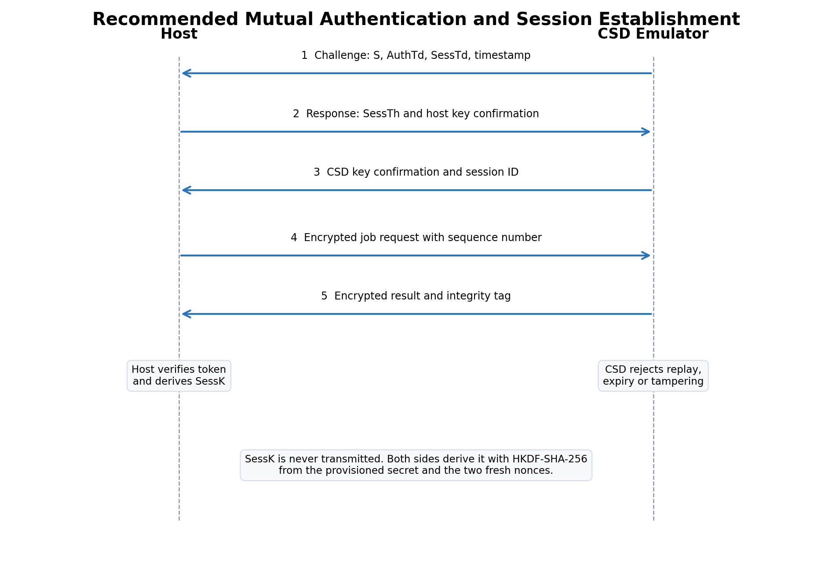
Figure 2. Recommended handshake and protected job exchange
- Provisioning: generate distinct 32-byte AuthK and EnK values for the Host-CSD pair. Store them in a local .env file excluded from version control. Assign stable host_id and csd_id values.
- Challenge: the CSD generates nonce S, created_at, expires_at, and handshake_id. It computes AuthTd = HMAC-SHA-256(AuthK, canonical transcript) and encrypts the challenge fields as SessTd using AES-256-GCM.
- Host verification: the Host decrypts SessTd, checks identities, time window, protocol version, and AuthTd using a constant-time comparison. Any mismatch terminates the handshake.
- Host response: the Host generates nonce R and derives SessK through HKDF-SHA-256 using the provisioned secret, salt derived from S and R, and context containing both identities and the protocol version. It returns R and a transcript confirmation inside SessTh.
- CSD verification: the CSD decrypts SessTh, checks that S, identities, expiry, and handshake_id match its pending state, derives the same SessK, verifies the confirmation, and marks the handshake_id consumed.
- Protected session: both sides exchange AES-GCM protected messages. Every message carries session_id, sequence number, direction, and message type as authenticated associated data. Sequence numbers may never repeat within a session.
- Close and expiry: the CSD removes expired sessions and replay-cache entries. A logout command immediately invalidates the selected session.

API Contract
Method and route | Purpose | Expected status
GET /health | Readiness check without secrets. | 200 ready
POST /api/v1/handshake/init | CSD creates S, AuthTd, SessTd, expiry, and handshake ID. | 201 challenge
POST /api/v1/handshake/complete | Host supplies SessTh and confirmation; CSD establishes the session. | 201 established or 401 rejected
POST /api/v1/secure/jobs | Submit encrypted in situ task command. | 202 accepted or 409 replay
GET /api/v1/secure/jobs/{id} | Return encrypted result when ready. | 200 result or 202 pending
DELETE /api/v1/secure/sessions/{id} | Invalidate a session. | 204 closed
GET /metrics/snapshot | Local demo metrics only; bind to localhost. | 200 metrics

Canonical Transcript
Never concatenate ambiguous strings. Serialize security-sensitive fields in a fixed order and encoding. For this prototype, use UTF-8 identities with a fixed JSON schema, sorted keys, compact separators, and explicit base64url for byte fields. The same serializer must be used on both sides.
challenge_transcript = {
"protocol": "SCK-1",
"handshake_id": handshake_id,
"host_id": host_id,
"csd_id": csd_id,
"nonce_s": base64url(nonce_s),
"created_at": created_at_utc,
"expires_at": expires_at_utc,
}
canonical = json.dumps(challenge_transcript, sort_keys=True,
separators=(",", ":")).encode("utf-8")
auth_td = HMAC_SHA256(AuthK, canonical)

Free Local Toolchain
The core path uses local software only. Installation downloads may require internet access, but no hosted runtime, paid API, trial, cloud account, or credit-card registration is part of the design.
Tool | Use | Cost and account requirement
Python 3.12 or newer | Protocol, API, tests, benchmarks, and reporting. | Free and open source; no account.
FastAPI and Uvicorn | CSD HTTP API and automatic local API documentation. | MIT-licensed; local use; no account.
pyca cryptography | AES-GCM, HMAC, HKDF, hashes, and secure primitives. | Open-source package; local use; no account.
Streamlit | Browser dashboard for the prototype and screenshots. | Open-source local framework; no cloud deployment needed.
Plotly and pandas | Interactive charts and result summaries. | Plotly.py is MIT-licensed and works without registration.
pytest and pytest-cov | Functional, security, and regression tests. | Free and open source; no account.
psutil | CPU and memory measurements. | Open source; no account.
Locust | Optional concurrent load testing. | Open source; local web UI; no account.
Podman Desktop with WSL 2 | Optional resource-constrained CSD container. | Open-source local container environment; no credit card.
OBS Studio | Screen and narration recording. | Free, open source, no watermark.
Shotcut | Optional trim, labels, and MP4 export. | Free and open source; no account.
Git and VS Code or VSCodium | Version control and editing. | Free local tools; remote account optional.

Minimum Hardware
Configuration | Recommendation
CPU | Any recent 4-core x64 processor. No GPU is required.
Memory | 8 GB for direct local processes; 12 to 16 GB preferred if Podman and OBS run together.
Storage | At least 3 GB free for Python, dependencies, test data, recordings, and exports.
Operating system | Windows 11. WSL 2 is needed only for the optional Podman profile.
Network | Not required after installation; all application traffic can remain on 127.0.0.1.

Repository Structure
safeconnectkey-prototype/
|-- README.md
|-- requirements.txt
|-- .env.example
|-- .gitignore
|-- host_app/
| |-- client.py
| |-- handshake.py
| `-- secure_jobs.py
|-- csd_app/
| |-- main.py
| |-- handshake.py
| |-- sessions.py
| |-- jobs.py
| `-- data_store.py
|-- shared/
| |-- schemas.py
| |-- canonical.py
| |-- crypto.py
| |-- keys.py
| `-- audit.py
|-- dashboard/
| `-- app.py
|-- validation/
| |-- run_benchmarks.py
| |-- run_attacks.py
| |-- analyze_results.py
| `-- acceptance.yaml
|-- tests/
| |-- test_handshake.py
| |-- test_crypto.py
| |-- test_replay.py
| |-- test_tamper.py
| `-- test_jobs.py
|-- csd_data/
| |-- sample.txt
| |-- sample.png
| `-- sample.wav
|-- results/
| |-- raw/
| |-- charts/
| `-- reports/
`-- scripts/
|-- generate_demo_keys.py
|-- generate_sample_data.py
|-- start_demo.ps1
`-- reset_demo.ps1

Implementation Phases
Phase | Work | Exit criterion
Phase 1 Project Skeleton | Create folders, virtual environment, settings model, structured logging, API health route, and test configuration. | Both processes start locally and /health returns ready.
Phase 2 Cryptographic Core | Implement byte encoding, canonical serialization, nonces, HMAC, HKDF, AES-GCM, constant-time verification, and unit tests. | Known-round-trip tests pass and modified tags always fail.
Phase 3 Handshake | Implement pending handshakes, challenge and response schemas, expiry, replay cache, key confirmation, session creation, and close. | Valid clients establish sessions; wrong key, expiry, and replay cases fail.
Phase 4 Secure Jobs | Implement encrypted request and result envelopes, monotonic sequence numbers, CSD data store, and four in situ jobs. | Host receives correct encrypted job results without downloading source data.
Phase 5 Dashboard | Add session state, handshake timeline, latest job, rejected-attack counter, CPU and memory panels, and results export. | One screen communicates the entire prototype state.
Phase 6 Validation | Automate correctness, security, performance, resource, and concurrency runs; save raw records before computing summaries. | Fresh run generates test logs, CSV files, charts, and pass or fail table.
Phase 7 Evidence | Capture final screenshot, record the planned demo, prepare README and validation report, and archive source plus results. | Submission package can be reproduced from a clean checkout.

Windows Setup
Run the following in PowerShell from the project directory. The first command should use the Python launcher installed from python.org or the Microsoft Store. If Python 3.12 is not installed, replace 3.12 with the available supported version.
py -3.12 -m venv .venv
.\.venv\Scripts\Activate.ps1
python -m pip install --upgrade pip
pip install fastapi "uvicorn[standard]" cryptography pydantic-settings `
httpx psutil pytest pytest-cov pandas plotly streamlit locust
python scripts\generate_demo_keys.py
python scripts\generate_sample_data.py

Start the Prototype
# Terminal 1
.\.venv\Scripts\Activate.ps1
uvicorn csd_app.main:app --host 127.0.0.1 --port 8001

# Terminal 2
.\.venv\Scripts\Activate.ps1
streamlit run dashboard\app.py --server.address 127.0.0.1

# Terminal 3
.\.venv\Scripts\Activate.ps1
python -m host_app.client demo

Optional Resource Constrained Profile
Use Podman only after the direct local version is stable. This isolates the CSD and allows repeatable CPU and memory limits. On Windows, Podman Desktop uses a WSL 2-backed machine; its official documentation lists 6 GB RAM for that machine. If the laptop has only 8 GB RAM, skip Podman and use process-level measurements instead.
podman build -t safeconnectkey-csd -f Containerfile .
podman run --rm --name safeconnectkey-csd `
--cpus 1 --memory 1g -p 127.0.0.1:8001:8001 `
--env-file .env safeconnectkey-csd

Implementation Rules
Rule | Implementation requirement
Key separation | AuthK and EnK must be independently generated. Derive separate handshake-confirmation and application-data subkeys from SessK.
Nonce uniqueness | Generate fresh random handshake nonces. For AES-GCM data messages, use a unique 96-bit nonce per key, preferably a random 32-bit prefix plus a 64-bit counter.
No key logging | Never write keys, raw session keys, plaintext protected payloads, or full authentication tokens to logs.
Safe evidence | For demonstration, display only shortened hashes and key fingerprints. A debug-only match indicator may show that both sides derived the same key fingerprint.
Strict schemas | Reject unknown fields, malformed base64, overlong identities, unsupported versions, and payloads above the configured size limit.
Replay cache | Persist consumed handshake IDs for at least the maximum token lifetime; track last accepted sequence number for each session.
Time handling | Use UTC and monotonic timing for benchmarks. Accept only a small configured clock skew in protocol timestamps.
Error discipline | Return generic authentication failures to clients; keep specific diagnostic reasons only in protected local audit logs.
Reproducibility | Save OS, CPU, Python version, dependency versions, Git commit, test configuration, sample hashes, and run timestamp with every benchmark.

Validation Strategy
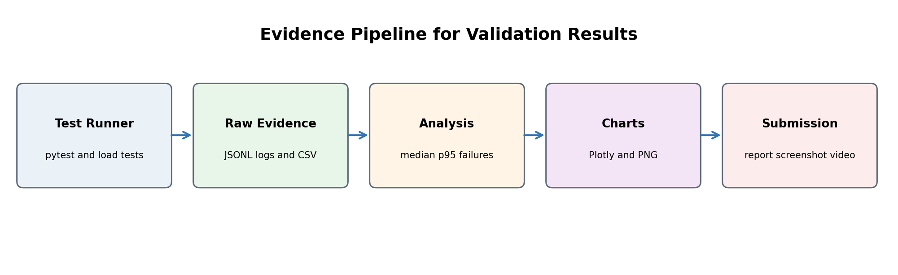
Figure 3. Raw evidence must be retained before any summary or chart is produced
Validation must answer five separate questions: Does the protocol work, does it reject attacks, does the CSD perform the intended tasks, what does it cost in time and resources, and can another person reproduce the result? The test suite below provides evidence for each question.

Functional and Security Test Matrix
ID | Test | Action | Expected result
V01 | Valid handshake | Correct keys and fresh tokens | Session established and both sides show the same session-key fingerprint.
V02 | Wrong authentication key | Change Host AuthK | Handshake rejected; no session created.
V03 | Wrong encryption key | Change Host EnK | AES-GCM decryption fails; no session created.
V04 | Tampered AuthTd | Flip one bit | Constant-time token check fails.
V05 | Tampered SessTd | Flip ciphertext or tag bit | Authenticated decryption fails.
V06 | Expired challenge | Advance time beyond expiry | Handshake rejected as expired.
V07 | Handshake replay | Resubmit consumed handshake ID | Rejected as replay.
V08 | Identity substitution | Change host_id or csd_id | AAD or transcript verification fails.
V09 | Valid secure job | Submit encrypted SHA-256 request | Correct digest returned inside encrypted response.
V10 | Data tampering | Change encrypted request byte | Job not executed; integrity check fails.
V11 | Message replay | Repeat accepted sequence number | Rejected; no duplicate execution.
V12 | Out-of-order message | Skip or lower sequence | Rejected according to configured sequence policy.
V13 | Session expiry | Submit after session TTL | Rejected; re-authentication required.
V14 | Unsupported operation | Request unknown job | Validated error; no arbitrary code execution.
V15 | Path traversal | Request ../ outside csd_data | Rejected; path remains inside allowlisted data root.
V16 | Oversized payload | Exceed configured request limit | Rejected before processing.
V17 | Concurrent sessions | Run 10 valid hosts | Sessions stay isolated and all valid jobs complete.
V18 | Restart behavior | Restart CSD during active session | Old session fails safely; a new handshake succeeds.

Performance and Resource Experiments
Experiment | Method | Metrics
Handshake latency | 20 warm-up handshakes, then 200 measured handshakes. Record each run; do not time dashboard rendering. | Median, p95, p99, minimum, maximum, failures.
Encryption and decryption | Benchmark 4 KB text, 512 KB image, and 5 MB audio payloads for 200, 100, and 30 iterations respectively. | Milliseconds per operation and MB/s.
In situ jobs | Run each supported job 100 times with the same fixed input files and hashes. | Job latency, result correctness, bytes avoided across the interface.
Resource use | Sample CSD process CPU and RSS every 100 ms during idle, handshake burst, and job workload. | Mean and peak CPU, mean and peak RSS memory.
Concurrency | Run 1, 5, 10, and 25 virtual Hosts for 60 seconds per level. | Requests/s, p95 latency, errors, peak CPU and memory.
Legacy comparison | Optional isolated AES-ECB/HMAC-MD5 profile using the same payloads and machine. | Performance difference only; label insecure.

Measurement Discipline
- Close unnecessary applications and keep the laptop connected to power. Record the Windows power mode.
- Use perf_counter_ns for elapsed time and psutil for process CPU and resident memory. Do not mix wall-clock and CPU time in one chart.
- Run at least three complete benchmark rounds and report all rounds. Prefer median and p95 over a single average.
- Hash every sample input and store the digest in run metadata so the text, image, and audio workloads are reproducible.
- Write raw records before analysis. The summary script must be rerunnable without repeating the benchmark.
- State whether the CSD ran as a normal process or inside a 1 vCPU and 1 GB container.
- Do not compare your Python measurements directly with the patent's Java or VM results unless the hardware, workload, iterations, and timing method are documented as different.

Engineering Acceptance Criteria
These are proposed pass criteria, not measured results. Adjust only before the final test run and record any change.
Category | Pass criterion
Correctness | All required valid functional tests pass.
Authentication | All wrong-key, tampered, expired, identity-substitution, and replay tests are rejected.
Confidentiality and integrity | No plaintext application payload is visible; modified ciphertext or AAD is rejected.
Key agreement | Fingerprints match for every valid session; no full key is logged.
Replay protection | No repeated handshake or message executes a job twice.
Availability | At 10 local clients, error rate stays below 1 percent and the service recovers after the run.
Resource suitability | Peak direct-process RSS stays below 256 MB and the container stays below 1 GB.
Latency target | Local p95 handshake latency stays below 100 ms on the declared laptop.
Reproducibility | A README-only clean setup reproduces tests, benchmarks, and result generation.

Result Files and Report Structure

Raw Record Schema
run_id,test_id,timestamp_utc,profile,host_id,csd_id,payload_type,
payload_bytes,operation,iteration,success,latency_ms,cpu_pct,rss_mb,
error_code,git_commit,python_version,os_build

Save one record per operation. For security tests, store only safe metadata such as error codes, truncated token fingerprints, and success status. Do not write secrets or plaintext protected content.

Required Validation Tables
- Test environment: device model, CPU, RAM, Windows build, Python version, execution profile, and dependency lock hash.
- Functional and security outcomes: test ID, expected result, observed result, pass/fail, and evidence file.
- Handshake performance: run count, median, p95, p99, minimum, maximum, and failure count.
- Payload performance: payload type, exact bytes, encryption and decryption median and p95, and throughput.
- Resource use: idle, handshake, and job workloads with mean and peak CPU and RSS.
- Concurrency: client count, throughput, p95 latency, error rate, and resource peaks.

Required Charts
- Handshake latency distribution using a box plot or histogram.
- Encryption and decryption time by exact payload size; do not compare only labels such as text, image, and audio without byte sizes.
- CPU and memory over time for the CSD process during a recorded workload.
- Concurrency level against throughput and p95 latency.
- Security test pass/reject summary. Use counts rather than a decorative percentage if the sample size is small.

Validation Results Writing Template
Use the following wording pattern after the system has been tested. Replace every bracketed field with a measured value and retain a reference to the raw result file.
Environment. The prototype ran on [CPU], [RAM] and [Windows build] using
Python [version]. The CSD executed as [local process / 1 vCPU, 1 GB container].

Correctness and security. [passed]/[total] required tests passed. All [count]
wrong-key, tampering, expiry and replay attempts were rejected, while [count]
valid handshakes completed successfully.

Performance. Across [count] measured handshakes after [count] warm-ups, median
latency was [x] ms and p95 latency was [y] ms. The peak CSD resident memory was
[z] MB. Detailed per-run values are stored in [CSV filename].

Payload processing. For [exact sizes], median encryption times were [values]
and median decryption times were [values]. The near-data jobs returned verified
results while avoiding transfer of [bytes] of source data.

Prototype Dashboard
Build one uncluttered dashboard page so the evaluator can understand the prototype from a screenshot. Use a top status row followed by the handshake trace, secure-job result, security-event table, and performance charts.
Area | Contents
Status row | CSD Online, Session Authenticated, Encryption AES-256-GCM, Profile Recommended, and current session age.
Handshake trace | Five numbered steps with green success or red rejection state; display shortened fingerprints only.
Secure job panel | Selected file, task, source size, returned result, bytes transferred, and verification status.
Security events | Timestamp, event type, safe reason code, and rejected or accepted status.
Performance | Handshake latency, latest job latency, CSD CPU, CSD RSS, and small trend charts.
Evidence controls | Run validation, simulate tamper, simulate replay, export CSV, and open results directory.

Prototype Image Checklist
- Use a 16:9 browser window at 100 percent zoom and hide unrelated tabs, bookmarks, usernames, and notifications.
- Show CSD Online and Session Authenticated.
- Show AES-256-GCM and HMAC-SHA-256 or HKDF-SHA-256 labels.
- Show one completed in situ task with a verified result.
- Show at least one rejected tamper or replay event without exposing sensitive values.
- Show two or three key metrics with units and a visible run timestamp.
- Export the screenshot as PNG at 1920 by 1080 or the display's native 16:9 resolution.

Prototype Video Plan
Record the demonstration in OBS Studio at 1080p and 30 fps. A 2 to 3 minute video is sufficient. Use window capture for the dashboard and terminal, disable desktop notifications, and rehearse once so the video contains no waiting or installation steps.
Time | Visual | Narration point
0:00 to 0:15 | Title and architecture diagram | The Host communicates securely with a simulated computational storage drive.
0:15 to 0:35 | Start CSD and dashboard | Everything runs locally with free tools; no cloud service or special hardware is required.
0:35 to 1:05 | Run valid handshake | Explain nonce S, nonce R, token verification, independent session-key derivation, and confirmation.
1:05 to 1:30 | Run secure SHA-256 or metadata job | The source file stays inside the CSD; only the authenticated command and small result cross the interface.
1:30 to 1:55 | Trigger tamper and replay demos | Both invalid requests are rejected and no duplicate job executes.
1:55 to 2:25 | Open validation results | Show pass/fail table, latency, CPU, memory, and payload charts.
2:25 to 2:40 | Final dashboard view | Summarize authenticated communication, lightweight local execution, and reproducible evidence.

Recording Settings
Setting | Value
Canvas and output | 1920 x 1080
Frame rate | 30 fps
Recording format | MKV for crash safety, then OBS remux to MP4
Audio | 48 kHz, microphone peak around -12 dB
Cursor | Visible; move slowly and avoid circling
Final filename | SafeConnectKey_Prototype_Demo.mp4

Suggested Seven Day Schedule
Day | Primary work | Evidence checkpoint
1 | Create repository, settings, health route, data generator, and tests skeleton. | Health screenshot and clean test discovery.
2 | Implement and unit-test cryptographic helpers. | Round-trip and tamper unit tests pass.
3 | Implement handshake, replay cache, session store, and close. | V01 to V08 pass.
4 | Implement secure jobs and sample text, image, and audio workloads. | V09 to V16 pass.
5 | Build dashboard and result export. | Draft prototype screenshot.
6 | Run benchmarks, resource tests, and concurrency tests; freeze raw evidence. | CSV files and charts generated.
7 | Write validation results, capture final image, record and edit video, package submission. | Final reproducibility check.

Risks and Mitigations
Risk | Mitigation
The evaluator expects physical CSD hardware | State that this is a functional software prototype and map every emulator component to the CSD blocks in the supplied drawings. Present hardware deployment as future work.
Results appear different from patent figures | Document machine, language, workload, payload bytes, iterations, and algorithm profile. Compare trends, not unmatched absolute values.
Windows or WSL resource limits are unstable | Complete the direct process profile first. Treat Podman as optional and record the actual mode used.
AES-GCM nonce reuse | Use a per-session random prefix plus monotonic counter and fail closed before counter exhaustion or state rollback.
Logs leak secrets | Centralize redaction; test logs for known demo keys and plaintext payload fragments before submission.
Dashboard affects benchmarks | Run benchmarks headlessly and let the dashboard read completed result files. Do not include UI rendering in protocol latency.
A negative test executes a job | Decrypt and validate the complete envelope, replay state, sequence, path, and operation allowlist before task dispatch.
Video failure or dropped frames | Record to MKV, keep a clean final screenshot, close heavy applications, and remux to MP4 after recording.

Final Submission Package
SafeConnectKey_Submission/
|-- SafeConnectKey_Validation_Report.pdf
|-- SafeConnectKey_Prototype.png
|-- SafeConnectKey_Prototype_Demo.mp4
|-- SafeConnectKey_Source.zip
|-- README.md
|-- results/
| |-- functional_security_results.csv
| |-- handshake_latency.csv
| |-- payload_crypto_results.csv
| |-- resource_usage.csv
| |-- concurrency_results.csv
| `-- charts/
`-- evidence/
|-- environment.txt
|-- dependency_versions.txt
|-- sample_hashes.txt
`-- pytest_output.txt

Definition of Done
- [ ] A clean setup on Windows launches the CSD, dashboard, and Host using the README.
- [ ] The Host and CSD independently derive the same session-key fingerprint without sending the key.
- [ ] All required positive tests pass and all required negative tests reject safely.
- [ ] Text, image, and audio validation uses exact documented byte sizes and file hashes.
- [ ] Raw results, summary tables, and charts are generated automatically.
- [ ] The final screenshot contains the authenticated state, secure task, security event, and key metrics.
- [ ] The final video demonstrates success, tamper rejection, replay rejection, and validation results.
- [ ] No key, secret, personal information, absolute local path, or unrelated notification appears in the submission.
- [ ] The validation report distinguishes measured results from targets and limitations.
- [ ] The source archive excludes .venv, secrets, caches, raw recordings, and temporary files.

Build Brief for an Agentic Coding Tool
The following compact brief can be supplied to a coding assistant after the repository is created. Review every security-sensitive change manually and require tests before accepting it.
Build a local Python prototype named SafeConnectKey with separate host_app and
csd_app processes. Preserve these seven logical modules: Nonce Generator, Key
Retriever, Token Generator, Session Token Generator, Communicator, Token
Verifier and Session Key Generator.

Use FastAPI, Uvicorn, pyca cryptography, Pydantic, httpx, pytest, psutil,
pandas, Plotly and Streamlit. Use AES-256-GCM, HMAC-SHA-256 and HKDF-SHA-256.
Use independent AuthK and EnK values loaded from ignored local environment
files. Never log secrets or plaintext protected payloads.

Implement versioned canonical JSON, mutual nonce challenge-response, explicit
key confirmation, five-minute session expiry, consumed-handshake replay cache,
and per-session monotonic message sequence numbers. Bind identities, protocol
version, message direction and sequence to authenticated associated data.

Keep sample files under csd_data. Implement allowlisted in situ jobs for
SHA-256, word count, image metadata, WAV metadata and compression. Prevent path
traversal and arbitrary command execution.

Create automated tests V01 through V18 from the implementation plan. Create a
benchmark runner that writes raw CSV before analysis and reports median, p95,
p99, CPU and RSS. Create a Streamlit dashboard for session state, handshake
timeline, secure job output, security events, charts and CSV export.

Do not implement MD5 or AES-ECB in the primary profile. If a legacy benchmark
is explicitly enabled, isolate it behind a disabled-by-default flag and label
all outputs insecure. Finish with a complete README and PowerShell start script.

Source Basis and Official Tool References
Supplied project specification. Method and System for Secure Communication Between Computational Storage Drives and Host System, Complete Specification, 25 pages.
Supplied project drawings. Figures 1 to 7 covering the CSD layers, component mapping, processor utilization, memory or storage use, and encryption/decryption timing.
FastAPI. Official documentation
pyca cryptography. Official documentation
pytest. Official documentation
Streamlit. Official documentation
Plotly for Python. Official documentation
Podman Desktop for Windows. Official documentation
OBS Studio. Official documentation
Shotcut. Official documentation

Conclusion
This plan converts the supplied invention into a buildable and assessable prototype using a single Windows laptop. The design demonstrates the original nonce, token, session, and near-data-processing ideas while replacing obsolete cryptographic choices with a defensible current profile. Most importantly, the prototype itself produces the exact evidence required for the submission: repeatable validation results, a clear prototype image, and a short end-to-end video.

